**Title**

Attendance

**Description**

Attendance is an application that will help university lecturers in determining the attendance of the students.

**Problem**

Many universities have a challenge of determining the attendance of their students. This application will help lecturers to determine the attendance of their students. Students will sign their attendance via a fingerprint which will help lecturers know the students who should sit for the end of semester exams by attending a minimum of 75% lectures.

This application will discourage absenteesm in class.

**UML symbols**

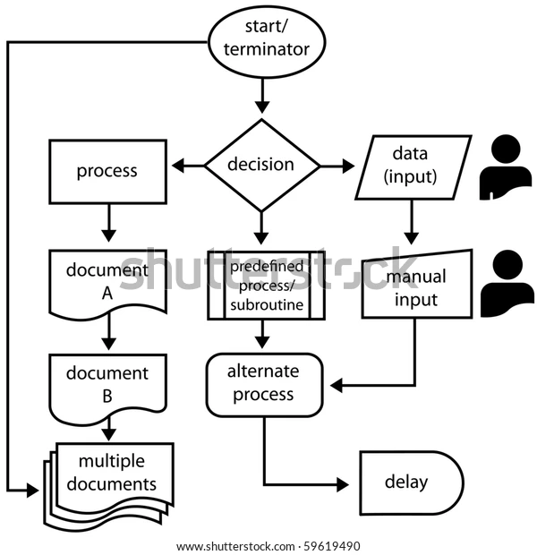

|  |  |  |
| --- | --- | --- |
| **ANSI/ISO Shape** | **Name** | **Description** |
|  | Flowline (Arrowhead)[[15]](https://en.wikipedia.org/wiki/Flowchart#cite_note-Myler1998-15) | Shows the process's order of operation. A line coming from one symbol and pointing at another.[[14]](https://en.wikipedia.org/wiki/Flowchart#cite_note-ShellyVermaat2011-14) Arrowheads are added if the flow is not the standard top-to-bottom, left-to right.[[15]](https://en.wikipedia.org/wiki/Flowchart#cite_note-Myler1998-15) |
|  | Terminal[[14]](https://en.wikipedia.org/wiki/Flowchart#cite_note-ShellyVermaat2011-14) | Indicates the beginning and ending of a program or sub-process. Represented as a [stadium](https://en.wikipedia.org/wiki/Stadium_(geometry)),[[14]](https://en.wikipedia.org/wiki/Flowchart#cite_note-ShellyVermaat2011-14) oval or rounded (fillet) rectangle. They usually contain the word "Start" or "End", or another phrase signaling the start or end of a process, such as "submit inquiry" or "receive product". |
|  | Process[[15]](https://en.wikipedia.org/wiki/Flowchart#cite_note-Myler1998-15) | Represents a set of operations that changes value, form, or location of data. Represented as a [rectangle](https://en.wikipedia.org/wiki/Rectangle).[[15]](https://en.wikipedia.org/wiki/Flowchart#cite_note-Myler1998-15) |
|  | Decision[[15]](https://en.wikipedia.org/wiki/Flowchart#cite_note-Myler1998-15) | Shows a conditional operation that determines which one of the two paths the program will take.[[14]](https://en.wikipedia.org/wiki/Flowchart#cite_note-ShellyVermaat2011-14) The operation is commonly a yes/no question or true/false test. Represented as a diamond ([rhombus](https://en.wikipedia.org/wiki/Rhombus)).[[15]](https://en.wikipedia.org/wiki/Flowchart#cite_note-Myler1998-15) |
|  | Input/Output[[15]](https://en.wikipedia.org/wiki/Flowchart#cite_note-Myler1998-15) | Indicates the process of inputting and outputting data,[[15]](https://en.wikipedia.org/wiki/Flowchart#cite_note-Myler1998-15) as in entering data or displaying results. Represented as a [rhomboid](https://en.wikipedia.org/wiki/Rhomboid).[[14]](https://en.wikipedia.org/wiki/Flowchart#cite_note-ShellyVermaat2011-14) |
|  | Annotation[[14]](https://en.wikipedia.org/wiki/Flowchart#cite_note-ShellyVermaat2011-14) (Comment)[[15]](https://en.wikipedia.org/wiki/Flowchart#cite_note-Myler1998-15) | Indicating additional information about a step in the program. Represented as an open rectangle with a dashed or solid line connecting it to the corresponding symbol in the flowchart.[[15]](https://en.wikipedia.org/wiki/Flowchart#cite_note-Myler1998-15) |
|  | Predefined Process[[14]](https://en.wikipedia.org/wiki/Flowchart#cite_note-ShellyVermaat2011-14) | Shows named process which is defined elsewhere. Represented as a rectangle with double-struck vertical edges.[[14]](https://en.wikipedia.org/wiki/Flowchart#cite_note-ShellyVermaat2011-14) |
|  | On-page Connector[[14]](https://en.wikipedia.org/wiki/Flowchart#cite_note-ShellyVermaat2011-14) | Pairs of labeled connectors replace long or confusing lines on a flowchart page. Represented by a small circle with a letter inside.[[14]](https://en.wikipedia.org/wiki/Flowchart#cite_note-ShellyVermaat2011-14)[[18]](https://en.wikipedia.org/wiki/Flowchart#cite_note-RFF-18) |
|  | Off-page Connector[[14]](https://en.wikipedia.org/wiki/Flowchart#cite_note-ShellyVermaat2011-14) | A labeled connector for use when the target is on another page. Represented as a [home plate](https://en.wikipedia.org/wiki/Baseball_field#Home_base)-shaped [pentagon](https://en.wikipedia.org/wiki/Pentagon).[[14]](https://en.wikipedia.org/wiki/Flowchart#cite_note-ShellyVermaat2011-14)[[18]](https://en.wikipedia.org/wiki/Flowchart#cite_note-RFF-18) |

**Other symbols**[[edit](https://en.wikipedia.org/w/index.php?title=Flowchart&action=edit&section=6)]

The ANSI/ISO standards include symbols beyond the basic shapes. Some are:[[17]](https://en.wikipedia.org/wiki/Flowchart#cite_note-IBM1970-17)[[18]](https://en.wikipedia.org/wiki/Flowchart#cite_note-RFF-18)

|  |  |  |
| --- | --- | --- |
| **Shape** | **Name** | **Description** |
| [Flowchart database](https://en.wikipedia.org/wiki/File:Flowchart_database.svg) | Data File or Database | Data represented by a [cylinder](https://en.wikipedia.org/wiki/Cylinder) symbolizing a disk drive. |
| [Flowchart Document](https://en.wikipedia.org/wiki/File:Flowchart_Document.svg) | Document | Single documents represented as a [rectangle](https://en.wikipedia.org/wiki/Rectangle) with a wavy base. |
| [Flowchart Document multiple](https://en.wikipedia.org/wiki/File:Flowchart_Document_multiple.svg) | Multiple documents represented as a stack of rectangles with wavy bases. |
| [Flowchar Manual input](https://en.wikipedia.org/wiki/File:Flowchar_Manual_input.svg) | Manual operation | Represented by a [trapezoid](https://en.wikipedia.org/wiki/Trapezoid) with the longest parallel side at the top, to represent an operation or adjustment to process that can only be made manually. |
| [Flowchart manual input](https://en.wikipedia.org/wiki/File:Flowchart_manual_input.svg) | Manual input | Represented by [quadrilateral](https://en.wikipedia.org/wiki/Quadrilateral), with the top irregularly sloping up from left to right, like the side view of a [keyboard](https://en.wikipedia.org/wiki/Computer_keyboard). |
| [Flowchart Preparation](https://en.wikipedia.org/wiki/File:Flowchart_Preparation.svg) | Preparation or Initialization | Represented by an elongated [hexagon](https://en.wikipedia.org/wiki/Hexagon), originally used for steps like setting a switch or initializing a routine. |